Exercise 3:
Sorting Customer Orders

1.Understand Sorting Algorithms:
different sorting algorithms (Bubble Sort, Insertion Sort, Quick Sort, Merge Sort).
Bubble Sort: This is the absolute simplest approach, but it is also the most inefficient. It works by repeatedly stepping through the list, comparing side-by-side elements, and swapping them if they are in the wrong order. This process causes the highest or lowest values to slowly "bubble" up to the top of the dataset.
Insertion Sort: This method builds a sorted array one item at a time. It grabs the next unsorted element and inserts it right into its correct position within the already-sorted section of the list. While this works beautifully for tiny datasets, it is terrible for handling massive amounts of data.
Merge Sort: This relies on a "divide and conquer" strategy. It continuously cuts your inventory exactly in half until it is broken down into single, individual items. From there, it merges those pieces back together in the perfect, correct order. It is highly efficient and incredibly predictable.
Quick Sort: This is another "divide and conquer" method, but it usually outperforms merge sort in real-world scenarios. It chooses a "pivot" element and throws everything larger than that pivot to one side, and everything smaller to the other. The algorithm then repeats this exact process on the remaining sections.

2. Setup:
We will implement this in Java. Create a new file named Order.java Create a file named OrderSorter.java to hold our algorithms
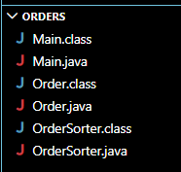

3.Implementation:
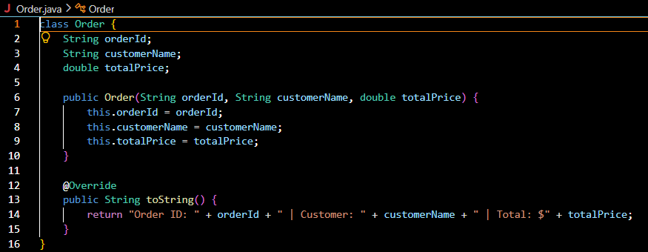
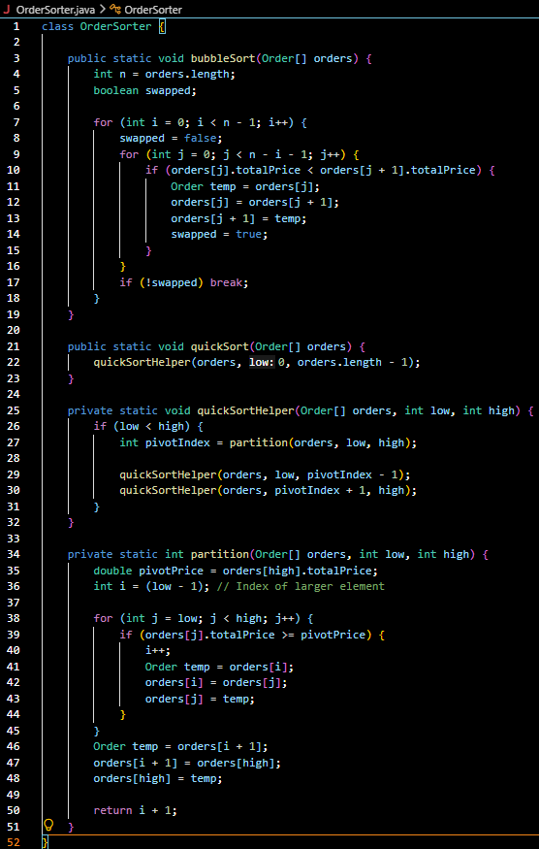
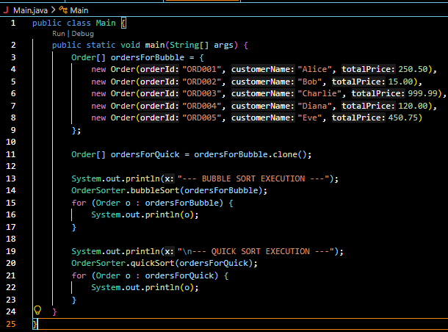
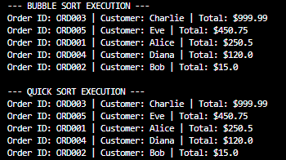

4.Analysis:
Algorithm Best-Case Average-Case Worst-Case (Big O)
Linear Search $O\left(n\right)$ $O\left(n^{2}\right)$ $O\left(n^{2}\right)$
Binary Search $O\left(nlogn\right)$ $O\left(nlogn\right)$ $O\left(n^{2}\right)$
We prefer Quick Sort
Bubble Sort uses a nested loop that scales terribly. For example, if you have 10,000 orders to process, your computer might have to run $10,000 \times 10,000$ operations, sky-rocketing the workload to 100 million checks. Quick Sort completely avoids this by dividing the data into fractional parts. Because of this logarithmic scaling, processing those exact same 10,000 orders only takes roughly $10,000 \times \log_2(10,000)$ operations, which drops the workload down to just about 132,000 checks.
This massive speed difference makes Quick Sort the clear choice for large datasets. Beyond raw speed, it offers two major hardware advantages. First, it sorts everything "in-place" directly within the original array by swapping elements, meaning it doesn't require extra memory to duplicate your data like Merge Sort does. Second, it is highly cache-efficient because modern CPUs read sequential arrays incredibly fast. Since Quick Sort simply slides two index pointers toward each other, it pairs perfectly with physical hardware caching to speed up processing even more.

